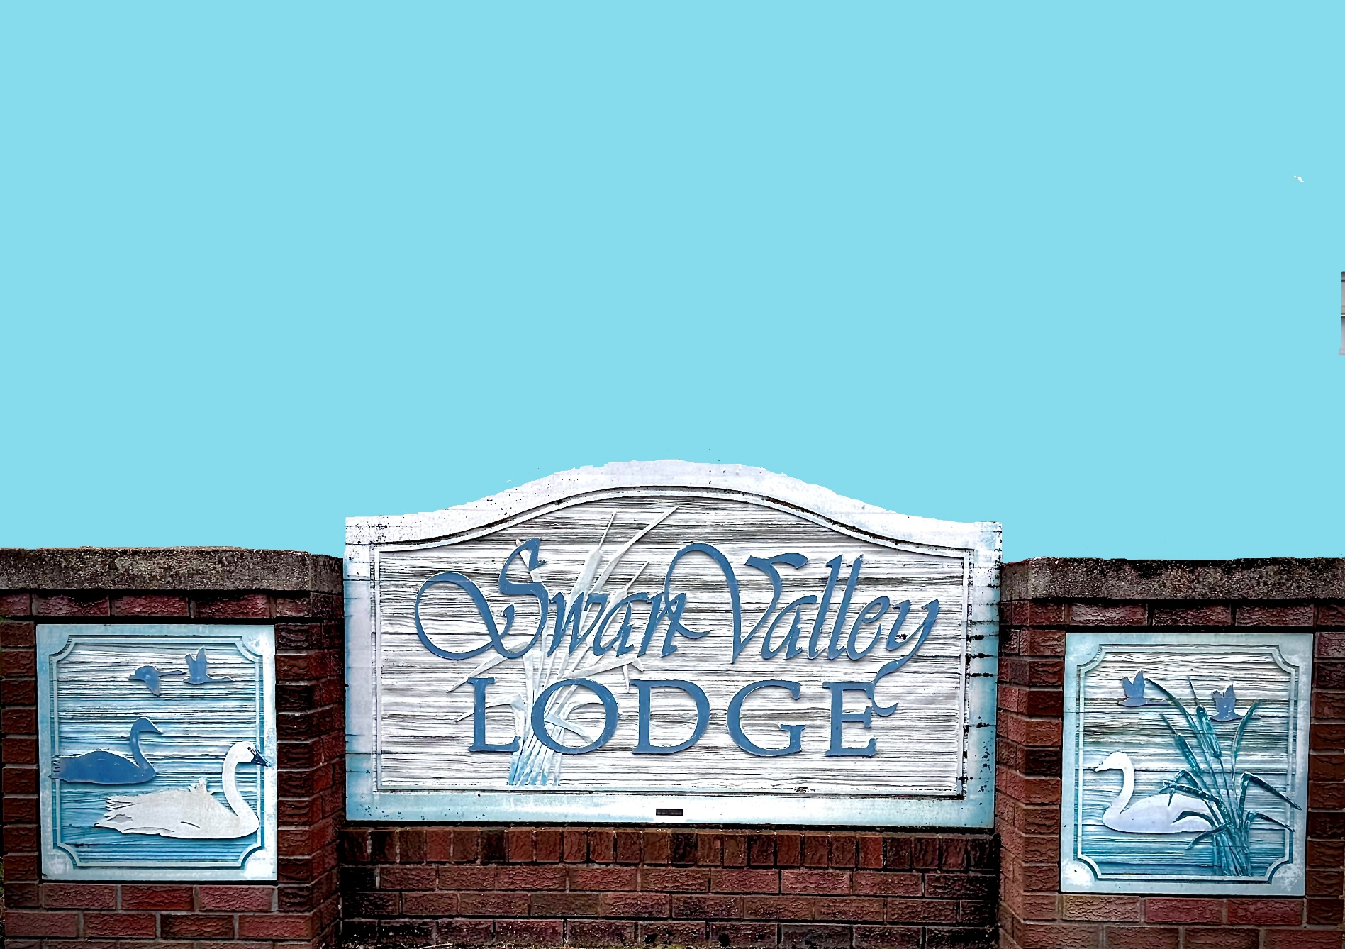
Community Learning Series presents

Kendra and Walter will share what Swan Valley Lodge is all about and will answer your questions. Come and learn about this long-term care home with 90 publicly funded beds, that seniors call home. This is an opportunity to learn about the programs, services and amenities that are available, including those available to non-Lodge residents. Everyone is welcome to attend this informal info session.
Where: Rotacrest Hall, upper level
When: Tuesday, July 28th at 11:00 am
Drop-in: $2.00
Hosted by New Horizons
info@crestonnewhorizons.ca

